“IGNATIAN APPETIZERS"
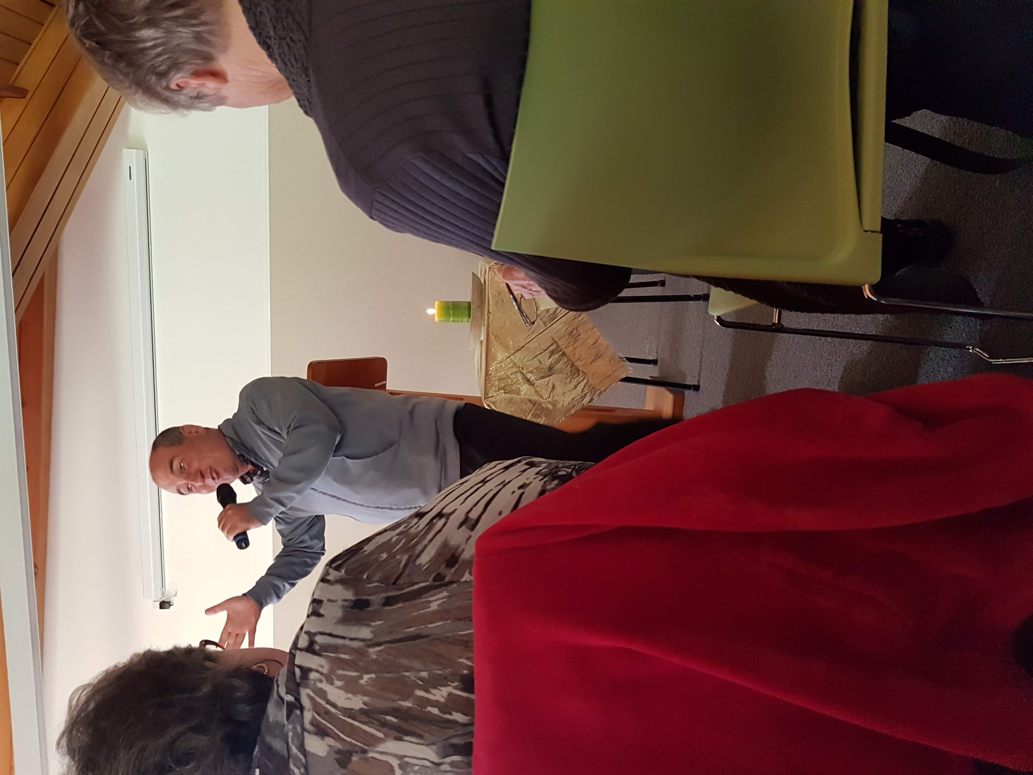
A smorgesboard can be a gourmet delight, and for those attending Ignatian Spirituality NZ’s recent workshop of Ignatian Appetizers at the Home of Compassion in Wellington, it was more than a banquet for the soul.
Describing himself as a lover of all things beautiful, Philip Chircop S.J. a Jesuit priest and internationally renowned retreat master, fed the 60 strong lay and religious attending, on a variety of spiritual “tapa’s”.
Unwrapping more than 20 rich tasters including themes on the pilgrim, journey, desert, intimacy, prayer, examen, breathing, listening, silence, generosity, flexibility and many more, retreatants enjoyed the opportunity to explore the mystery of God in all things.
Philip’s hope “that hearts, minds and souls would be stretched as we could become detached enough to allow ourselves to be found by God in all moments and aspects of our lives”. His lively and engaging presentation was indeed a feast to dine on with many take-aways to further reflect on and explore.
Perhaps Eph3:14:19 sums up quite well how so many of us who were fortunate enough to hear Philip felt by the end of the two days - “may you be filled with the fullness of God” and indeed we were. To find more on Philip go to A-Mused: http://www.philipchircop.com
Katie O’Connor is a Graduate of Te Wairua Mahi. Ignatian Spirituality New Zealand’s formation in Spiritual Direction in the Ignatian Tradition ignatianspirituality.nz
